8 Phase of SDLC: Plan code build test deploy release operate and monitor

Goal of Devops: bringing efficiency and effectiveness in SDLC. (Cultural change)

Two pillar of application 1) Development Team 2) Operation Team

How Development team works?

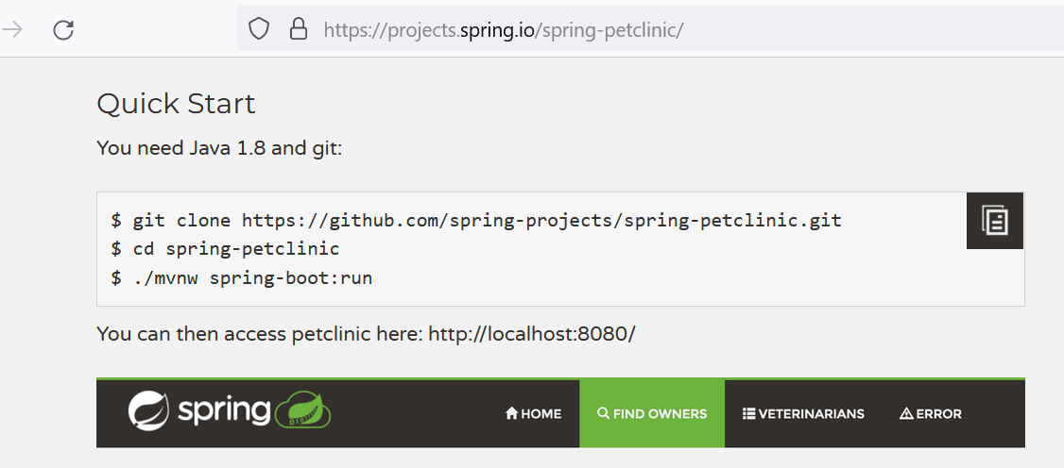

How Operation team works? >> Create infra as per Application team, and run software.

